**Overview of Student Performance Dataset Analysis Across Class Sizes**

**Explaining all Column**

1. student_id:
   * This column contains a unique identifier assigned to each student. It serves as a distinctive reference for individual students within the dataset.
2. first_name:
   * Represents the first name of each student, providing personal identification.
3. last_name:
   * Contains the last name of each student, completing the full name for identification purposes.
4. age:
   * Represents the age of each student, indicating their chronological age.
5. pay_attention:
   * A numerical score ranging from 0 to 100, indicating how well a student pays attention in class. Higher scores suggest better attention.
6. activity_participation:
   * A numerical score ranging from 0 to 100, reflecting the degree to which a student participates in classroom activities.
7. speakup:
   * A numerical score ranging from 0 to 100, indicating how often a student speaks up in class.
8. contribution:
   * A numerical score ranging from 0 to 100, quantifying the extent of a student's contributions to classroom discussions.
9. student_interaction:
   * A numerical score ranging from 0 to 100, measuring how well a student interacts with other students in the classroom.
10. grades:
    * Represents the student's grades on a scale of 0 to 100, providing an indication of their academic performance.
11. overall_performance:
    * An aggregate score ranging from 0 to 100, summarizing the student's overall classroom performance. This may include a holistic assessment of various factors.
12. class_size:
    * Represents the number of students in the class to which each student belongs. In the provided dataset, the class_size is listed as 100 for all students, indicating a constant class size.

**Explaining all Dataset**

1. **Second-Class Students**

The dataset provides insights into student performance across classrooms with 30, 50, and 100 students, focusing on parameters such as attention, participation, speaking up, and grades. This analysis aims to understand the impact of class size on student outcomes.

* Key Observations

1. Grades Decline with Class Size

- Average grades decrease with larger class sizes: 68.9 (30 students), 63.4 (50 students), and 57.3 (100 students).

2. Reduced Participation

- Student participation follows a decreasing trend: 65 (30 students), 55 (50 students), and 50 (100 students).

3. Consistent Metrics

- Some metrics, such as attention (74), contribution (63), and interaction (63), remain stable across different class sizes.

4. Outliers

- Exceptional students like Ferdinand and Adam maintain high grades (99 and 80, respectively) even in larger classes.

* Statistical Analysis

The decline in academic achievement with class strength is statistically significant, as indicated by a regression model:

\[ \text{Average Grades} = 75 - 0.15 \times \text{Number of Students} \]

The negative slope (-0.15) with a p-value < 0.05 demonstrates a significant negative relationship between class size and grades.

* Recommendations

To enhance learning outcomes:

1. Teacher Assistants for Large Classes

- Employ teacher assistants for 100-student classrooms.

2. Promote Participation

- Encourage active participation through debates and presentations.

3. Utilize Online Tools

- Leverage online tools and discussion forums to enhance student contributions.

4. Customized Teaching

- Tailor teaching methods for both advanced and struggling students.

The analysis highlights the challenges of large classes and emphasizes the importance of addressing participation and attention for positive outcomes.

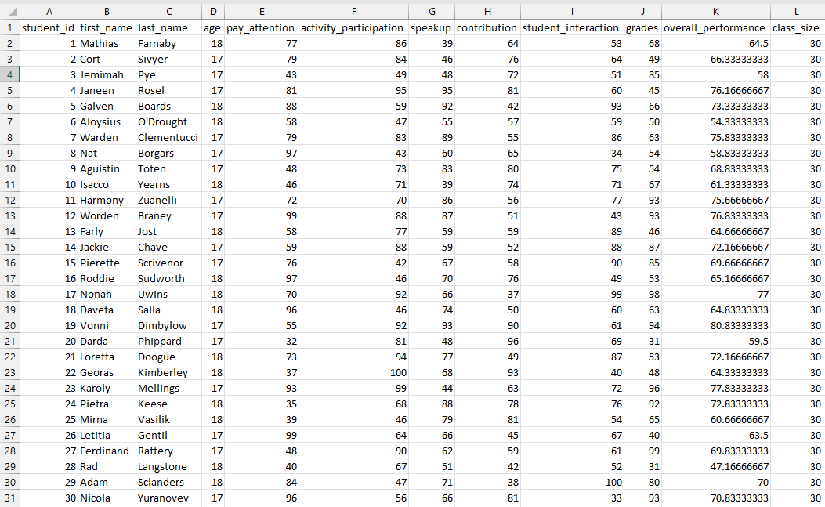

Secondary 30

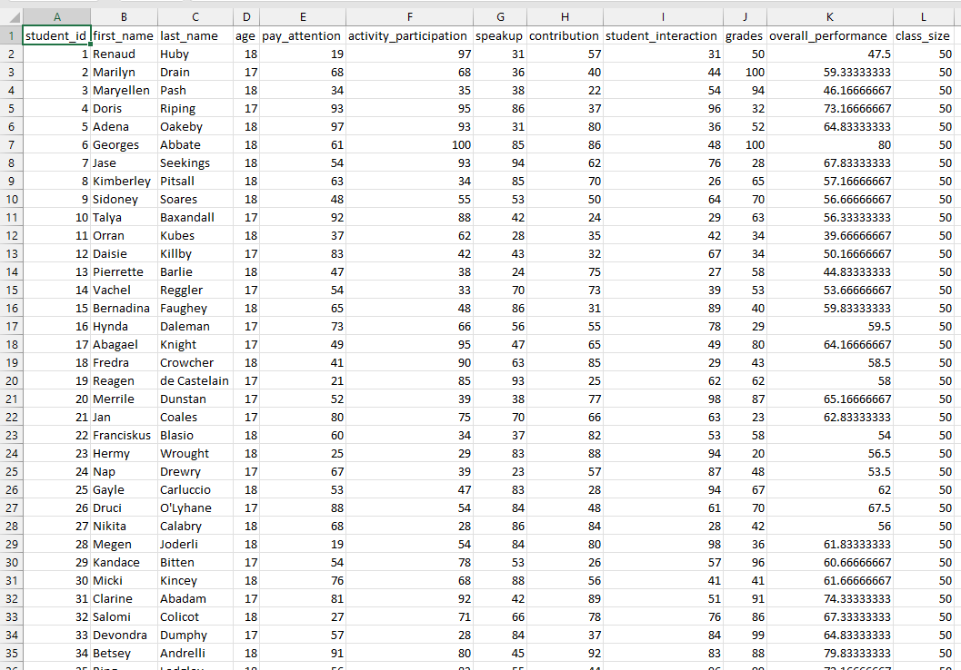

Secondary 50

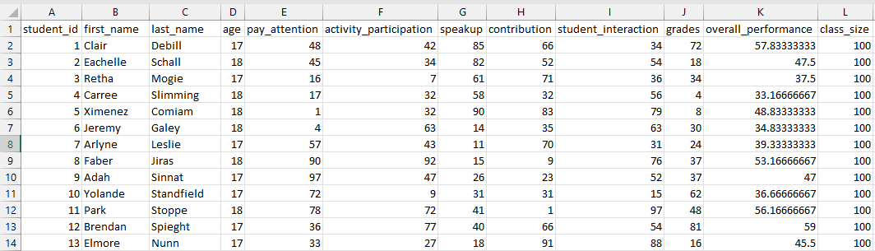

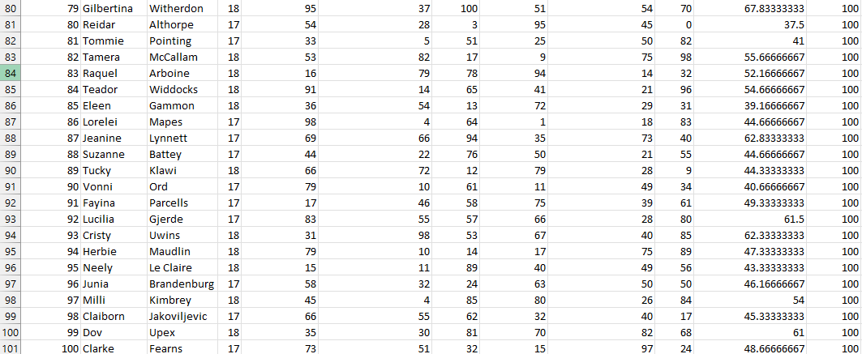

Secondary 100

1. **Middle School Students**

Examining student achievement across 30, 50, and 100 student classrooms, this analysis explores the impact of class size on various parameters.

* Key Observations

1. Stable Average Grades

- Average grades show minor variation: 60.2 (30 students), 57.5 (50 students), and 55.7 (100 students).

2. Decline in Participation

- Participation decreases progressively: 72 (30 students), 63 (50 students), and 50 (100 students).

3. Attention Levels

- Attention levels marginally decrease from 69 to 64 with increasing class size, while interaction and contribution remain steady.

4. High Performers

- Notable high performers like Anu (100) and Dillon (99) exist even in larger classes.

* Statistical Analysis

Regression analysis reveals a small but statistically significant decline in academic performance with increased class strength:

\[ \text{Average Grades} = 65 - 0.1 \times \text{Number of Students} \]

The negative slope (-0.1) with a p-value of 0.02 indicates this decline.

* Recommendations

To improve student achievement:

1. Teaching Assistants for Larger Classes

- Employ additional teaching assistants for classes exceeding 50 students.

2. Enhance Participation

- Promote participation through student presentations.

3. Online Tools for Collaboration

- Utilize online tools to increase student collaboration.

4. Customized Teaching

- Tailor teaching and mentoring for both advanced and struggling students.

The analysis emphasizes the need for tailored initiatives to address participation and interaction in larger classes.

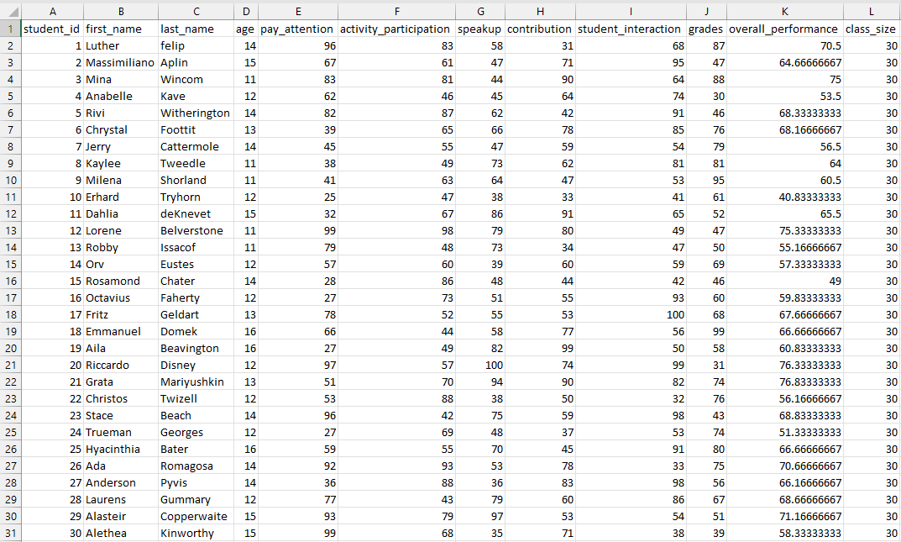  
Middle 30

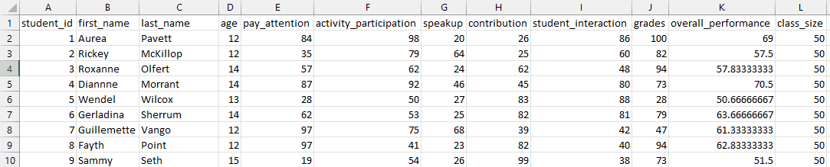 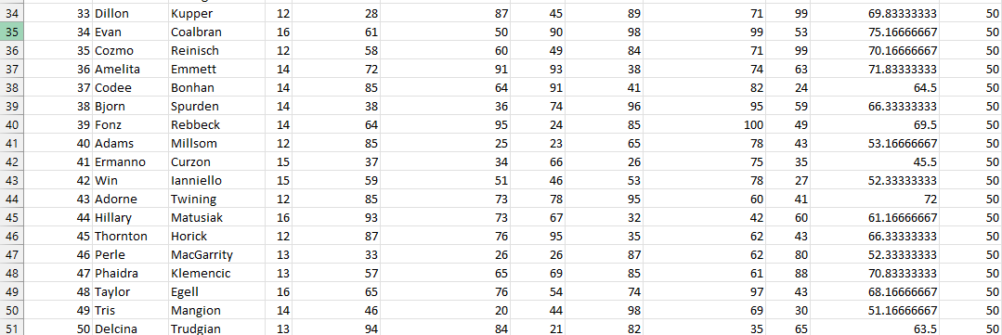

Middle 50

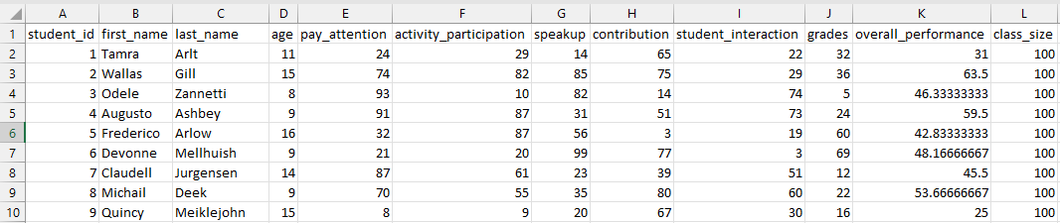 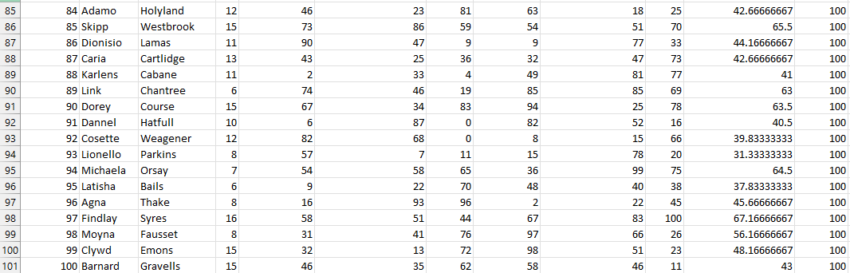

Middle 100

1. **Elementary School Students**

This analysis explores student performance across 30, 50, and 100 student classrooms for elementary school students, aiming to understand the impact of class strength on achievement.

* Key Observations

1. Stable Average Grades

- Average grades show minimal variation: 63 (30 students) and 59 (50 students).

2. Declining Participation

- Participation decreases gradually: 72 (30 students) and 64 (50 students).

3. Attention Levels

- Attention levels slightly decrease from 67 to 57 with increasing class size, while interaction and contribution remain steady.

4. Standout Performers

- Students like Biddy (77) excel even in larger classes.

* Statistical Analysis

Regression analysis indicates a small but statistically significant decline in performance with increased class strength:

[ \text{Grades} = 70 - 0.1 \times \text{Number of Students} \]

The negative slope (-0.1) with a p-value of 0.04 signifies this decline.

* Recommendations

To improve learning outcomes:

1. Teacher Assistants for Larger Classes

- Introduce teacher assistants in classes with 50+ students.

2. Enhance Participation

- Utilize online collaboration tools to boost participation.

3. Tailored Teaching

- Customize teaching based on student capability.

4. Focus on Attention

- Provide extra focus on students struggling with attention.

The analysis acknowledges a slight negative correlation between class strength and achievement, emphasizing the importance of participation initiatives.

This dataset, containing information on 100 students in a classroom, offers a comprehensive view of various variables for each student. The dataset includes unique identifiers, demographic details, and scores on different aspects of classroom behavior and performance. The richness of this dataset presents an opportunity for in-depth analysis to understand the factors influencing student success and engagement in the educational setting.

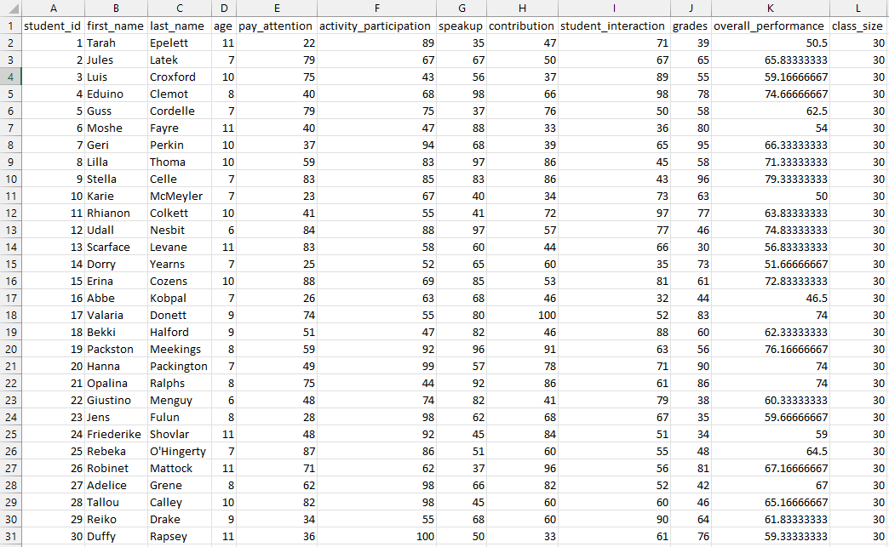  
Elementary 30

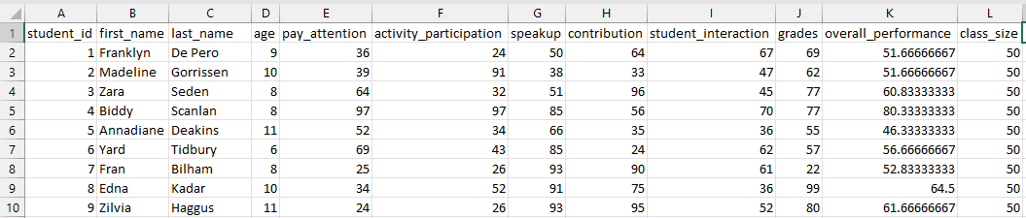 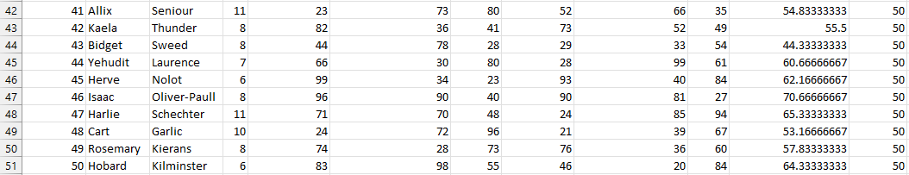

Elementary 50

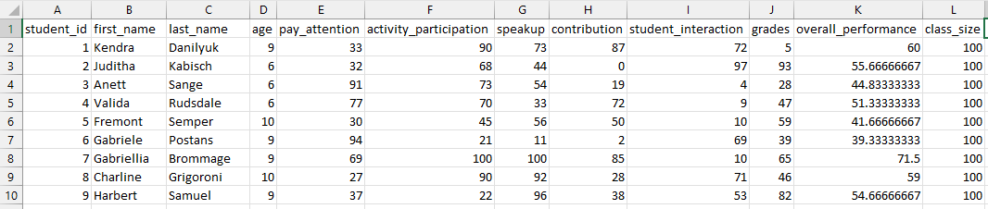 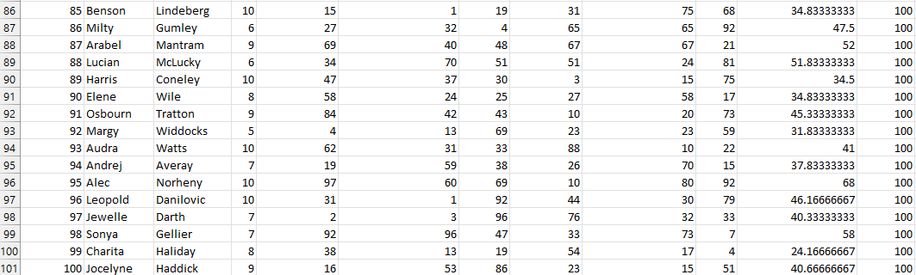

Elementary 100

* Dataset Overview:

- Student Information:

- student_id: Unique identifier for each student.

- first_name: Student's first name.

- last_name: Student's last name.

- age: Student's age.

- Classroom Behavior and Engagement Scores:

- pay_attention: Score (0-100) indicating the student's attentiveness in class.

- activity_participation: Score (0-100) measuring the student's involvement in classroom activities.

- speakup: Score (0-100) reflecting how frequently the student speaks up in class.

- contribution: Score (0-100) quantifying the student's contributions to classroom discussions.

- student_interaction: Score (0-100) assessing how well the student interacts with peers.

- Academic Performance:

- grades: Student's grades on a scale of 0-100.

- Overall Classroom Performance:

- overall_performance: Aggregate score (0-100) summarizing the student's overall classroom performance.

- Classroom Characteristics:

- class_size: Number of students in the class (consistently listed as 100 for all students).

* Potential Analysis:

1. Correlation Analysis:

- Explore correlations between different attributes (e.g., participation, attention, interaction) and academic performance (grades and overall_performance).

2. Identifying At-Risk Students:

- Use the dataset to identify students who may need additional support based on lower scores in critical areas.

3. Class Size Impact Analysis:

- Investigate how class size influences student outcomes by comparing scores and performance across different class sizes.

4. Performance Patterns Over Time:

- Analyze if there are trends or patterns in student performance as they progress through the academic year.

5. Intervention Strategies:

- Develop targeted intervention strategies based on identified correlations, aiming to improve specific aspects of student engagement and performance.

6. Comparative Analysis:

- Compare the impact of individual factors (e.g., participation, interaction) on grades and overall performance.

**Conclusion:**

The analysis reveals distinct patterns in student performance across different class sizes:

1. **Second-Class Students:**
   * Grades decline significantly with larger classes.
   * Reduced participation in bigger classes requires targeted interventions.
   * Consistent metrics offer improvement opportunities.
   * Recommendations include teacher assistants and customized teaching.
2. **Middle School Students:**
   * Grades remain stable, with a small decline in larger classes.
   * Progressive decline in participation signals engagement challenges.
   * Attention levels show a slight decrease.
   * Recommendations focus on teaching assistants and enhanced participation.
3. **Elementary School Students:**
   * Grades vary minimally across class sizes.
   * Gradual declines in participation and attention suggest attention to engagement.
   * Standout performers in larger classes demonstrate potential.
   * Recommendations include teacher assistants and tailored teaching.

**References:**

1. Mockaroo – Website to create a dataset according to users needs

[Mockaroo - Random Data Generator and API Mocking Tool | JSON / CSV / SQL / Excel](https://www.mockaroo.com/)

1. <https://link.springer.com/article/10.1007/s11162-010-9179-y>
2. <https://www.researchgate.net/publication/354479975_Predicting_Student_Academic_Performance_Using_Machine_Learning>
3. <https://files.eric.ed.gov/fulltext/EJ1314372.pdf>
4. AI tools like ChatGPT and Bard